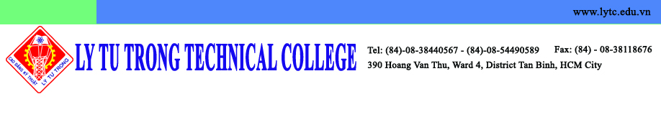

Kunsan National University
Institute of International Affairs & Language Education
558 Daehak Road, Gunsan, Jeollabukdo, 573-701, Korea

May 22, 2015

Dear Dr. Seman PYO, Director of Institute of IALE,

On behalf of Ly Tu Trong Technical College, I was very honored to have a chance to welcome you to visit our campus. To my deep regret I wasn’t there to welcome you due to my business trip.

This visit contributed to promoting cooperation between Kunsan National University (KNU) and Ly Tu Trong Technical College (LTTC), including the MOU and agreement for students and faculty exchange.

I am looking forward to paying a visit to KNU in return to your goodwill for visiting LTTC. I would be grateful if you could inform me about the convenient time for you.

Sincerely yours,

Dr. Pham Huu Loc
Rector of Ly Tu Trong Technical College
Ho Chi Minh City

